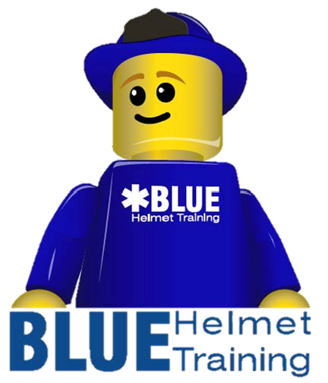
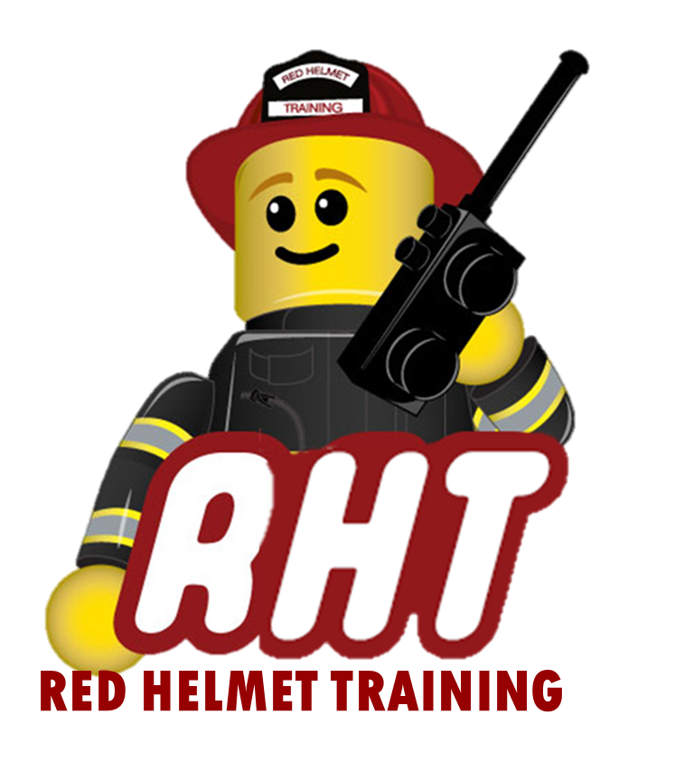
Red Helmet Training
Proudly Presents
Fireline EMT / Paramedic

Dates: August 5th and 6th, 2024 (Both Days)

Times: 9:00 a.m. – 5:00 p.m.

Location: Red Helmet Training
10601 Church Street Suite #107
Rancho Cucamonga, CA 91730

Instructor: Red Helmet Training Staff

Fees / Materials: $300 .00 – Payable to Red Helmet Training
This course issues a CSFM Certificate

Class Description: This course will cover necessary information for EMT -1, EMT-2, and Paramedics to function as a Single Resource on Wildland Fires. The class will review the typical emergencies, equipment needs, interface with the MEDL, emergency evacuations, wildland safety considerations, navigation and responsibilities. This class gives the Fireline EMT/ P or those pursuing the position practical advice on current guidelines for the position.

This course will require a minimum of 10 students.

To register for this course please visit the web site.


www.RedHelmetTraining.com

Red Helmet Training

Playing to Learn, Learning to Play

Red Helmet Training

Playing to Learn, Learning to Play
www.RedHelmetTraining.com

Course Registration Form

Student Name: Course:

Course Dates: Course Location:

Home Address: City: Zip:

Home Phone: Cell:

E-Mail Address:

Organization: Title:

To be added to the e-mail list for upcoming classes please visit the Red Helmet Training website.

Reservations are required for all classes unless specified. No phone reservations will be accepted.
You must send in a check or pay electronically to reserve your seat. If your department is paying for you to attend then we will shred your personal check or refund your electronic payment upon receipt of your department check. Checks are not processed until the last day of class so please plan accordingly. Checks should be dated for the last day of the course. Dress code for the facility is business casual or department uniform. No shorts or flip flops will be allowed.

You must call at least one week in advance to cancel or your fee will be retained. You will receive a confirmation e-mail once we have processed your reservation form, along with any course instructions. Any course prerequisites or materials required will be listed on the class flyer. These items are your responsibility to bring to class the first day. If you do not have them you will be dropped from class.

Reservations are on a first come basis unless spots are held by the sponsoring agency / department.
California State Fire Marshal CFSTES and CSTI certificates may take 6 to 8 weeks to process.

If you have any questions, please contact the primary instructor for the course.

Please complete this form and submit with your payment made payable to Red Helmet Training.

Mail all registration forms with payments to:

Red Helmet Training
10601 Church Street #107
Rancho Cucamonga, CA 91730

