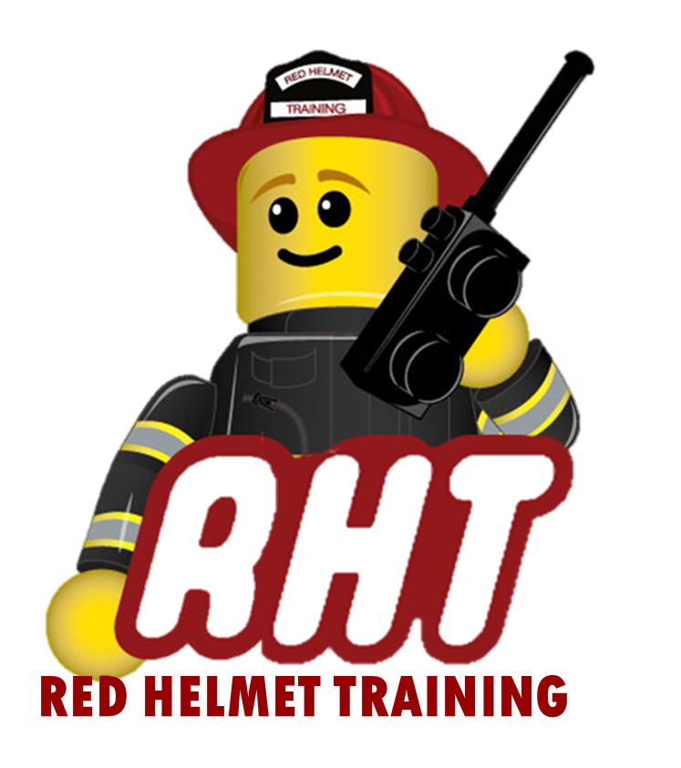
Red Helmet Training
Fire Inspector Courses

Announce: Fire Marshal 1B – Community Relations &
Fire and Life Safety Education

Dates: August 17 and 18, 2024

Times: 8:00 a.m. – 6:00 p.m.

Location: Red Helmet Training Classrooms
10601 Church Street #107
Rancho Cucamonga CA 91730

Instructor: Battalion Chief Brian Pachman

Course Fees: $340.00 – Payable to Red Helmet Training

Req. Materials: Fire and Life Safety Educator
IFSTA (3rd Edition) ISBN: 978087939396

Class Description: This course provides an overview of the knowledge and skills needed to manage community relations and fire and life safety education programs including developing relationships; presenting safety proposals; creating media communication strategies and policies and participating in media interviews; creating a collaborative fire and life safety education partnership; managing a fire and life safety education strategy, an organizational awareness campaign, and implementing and evaluating fire and life safety programs.
To register for this course please visit the web site.



www.RedHelmetTraining.com

Red Helmet Training

Playing to Learn, Learning to Play
Red Helmet Training

Playing to Learn, Learning to Play
www.RedHelmetTraining.com

Course Registration Form

Student Name: Course:

Location: Dates:

Home Address: City: Zip:

Home Phone: Cell:

E-Mail Address:

Organization: Title:

To be added to the e-mail list for upcoming classes please visit the Red Helmet Training website.

Reservations are required for all classes unless specified. No phone reservations will be accepted.
You must send in a check or pay electronically to reserve your seat. If your department is paying for you to attend then we will shred your personal check or refund your electronic payment upon receipt of your department check. Checks are not processed until the last day of class so please plan accordingly. Checks should be dated for the last day of the course. Dress code for the facility is business casual or department uniform. No shorts or flip flops are allowed.

You must call at least one week in advance to cancel or your fee will be retained. You will receive a confirmation e-mail once we have processed your reservation form, along with any course instructions. Any course prerequisites or materials required will be listed on the class flyer. These items are your responsibility to bring to class the first day. If you do not have them you will be dropped from class.

Reservations are on a first come basis unless spots are held by the sponsoring agency / department.
California State Fire Marshal CFSTES and CSTI certificates may take 6 to 8 weeks to process.

If you have any questions, please contact the primary instructor for the course.

Please complete this form and submit with your payment made payable to Red Helmet Training.

Mail all registration forms with payments to:

Red Helmet Training
10601 Church Street #107
Rancho Cucamonga, CA 91730

