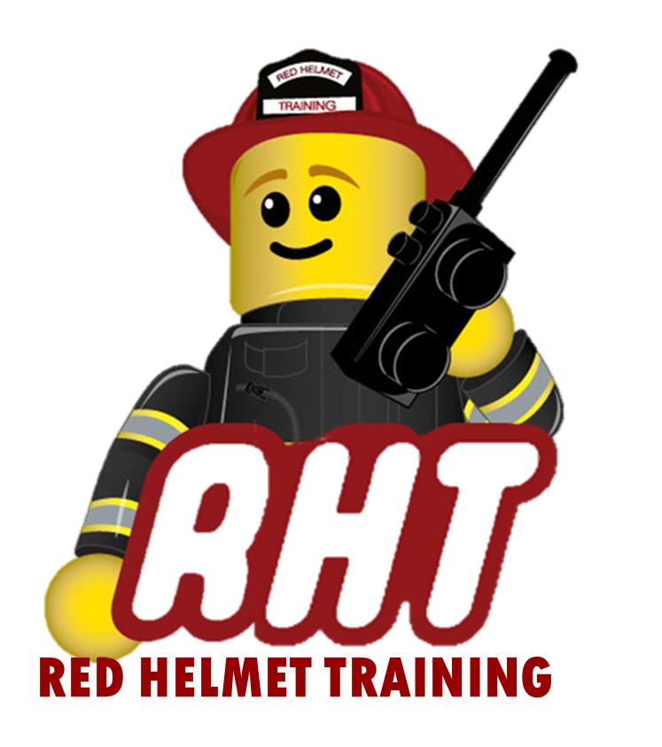
Red Helmet Training
Company Officer Courses

Course: Company Officer 2A
Human Resource Management

Dates: April 7, 8, 9, 10, and 11, 2025 (8am – 5)

Location: Red Helmet Training Central
3437 West Shaw Avenue
Fresno, CA 93711

Instructor: Shane Brown & Jesse Quinalty

Fees / Materials: $440.00 – Payable to Red Helmet Training.
This class is limited to 30 students

Required Text IFSTA Company Officer 6th Edition
ISBN 978-087939564-3

Class Description: This course provides information on the use of human resources to accomplish assignments, evaluating member performance, supervising personnel, and integrating health and safety plans, policies, and procedures into daily activities as well as the emergency scene.

Prerequisite: CSFM Firefighter II Completion

To register for this course please visit the web site.


www.RedHelmetTraining.com

Red Helmet Training

Playing to Learn, Learning to Play

Red Helmet Training

Playing to Learn, Learning to Play
www.RedHelmetTraining.com

Course Registration Form

Student Name: SFT ID#:

Course / Location: Dates:

Home Address: City: Zip:

Home Phone: Cell:

E-Mail Address:

Organization: Title:

To be added to the e-mail list for upcoming classes please visit the Red Helmet Training website.

Reservations are required for all classes unless specified. No phone reservations will be accepted.
You must send in a check or pay electronically to reserve your seat. If your department is paying for you to attend then we will shred your personal check or refund your electronic payment upon receipt of your department check. Checks are not processed until the last day of class so please plan accordingly. Checks should be dated for the last day of the course. Dress code for the facility is business casual or department uniform. No shorts or flip flops are allowed.

You must call at least one week in advance to cancel or your fee will be retained. You will receive a confirmation e-mail once we have processed your reservation form, along with any course instructions. Any course prerequisites or materials required will be listed on the class flyer. These items are your responsibility to bring to class the first day. If you do not have them you will be dropped from class.

Reservations are on a first come basis unless spots are held by the sponsoring agency / department.
California State Fire Marshal CFSTES and CSTI certificates may take 6 to 8 weeks to process.

If you have any questions, please contact the primary instructor for the course.

Please complete this form and submit with your payment made payable to Red Helmet Training.

Mail all registration forms with payments to:
Red Helmet Training
8560 Vineyard Avenue #301
Rancho Cucamonga, CA 91730

