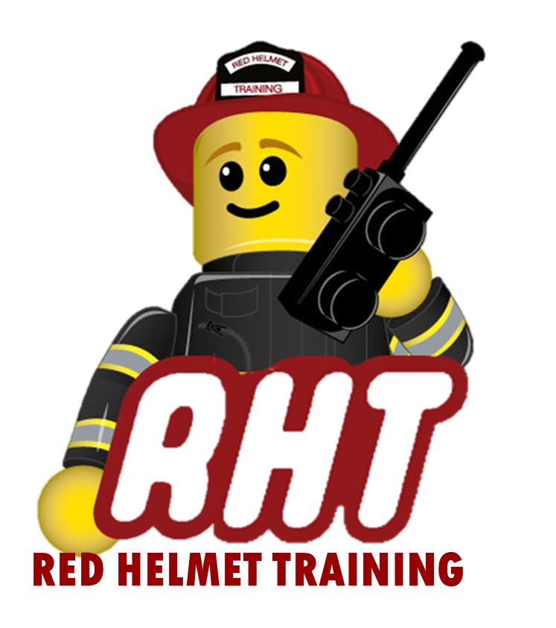
Red Helmet Training
Company Officer Courses

Announce: Instructor 1 – Instructional Methodology

Dates: September 29, 30, Oct. 1, 2, and 3, 2025

Times: 8:00 a.m. – 5:00 p.m.

Location: South Ops Riverside
23300 Castle Street
Riverside, CA 92518

Instructor: John Price & Jesse Quinalty

Fees / Materials: $450.00 – Payable to Red Helmet Training

Required Text: IFSTA Fire & Emergency Services Instructor

Class Description: This course provides the skills and knowledge needed for the entry level professional instructor to perform his or her duties safely, effectively, and competently. The curriculum is based on the 2025 edition of NFPA 1041.
At the end of this course, candidates for Instructor I certification will be able to teach and deliver instruction from a prepared lesson plan utilizing instructional aids and evaluation instruments. The Instructor I will also be able to adapt a lesson plan and complete the reporting requirements to the local jurisdiction.

To register for this course please visit the web site.


www.RedHelmetTraining.com

Red Helmet Training

Playing to Learn, Learning to Play
Red Helmet Training

Playing to Learn, Learning to Play
www.RedHelmetTraining.com

Course Registration Form

Student Name: SFT ID#:

Course / Location: Dates:

Home Address: City: Zip:

Home Phone: Cell:

E-Mail Address:

Organization: Title:

To be added to the e-mail list for upcoming classes please visit the Red Helmet Training website.

Reservations are required for all classes unless specified. No phone reservations will be accepted.
You must send in a check or pay with PayPal to reserve your seat. If your department is paying for you to attend then we will shred your personal check or deny your PayPal payment upon receipt of your department check. PayPal payments and Checks are not processed until the last day of class so please plan accordingly. Checks should be dated for the last day of the course. Dress code for the facility is business casual or department uniform. No shorts or flip flops will be allowed.

You must call at least one week in advance to cancel or your fee will be retained. You will receive a confirmation e-mail once we have processed your reservation form, along with any course instructions. Any course prerequisites or materials required will be listed on the class flyer. These items are your responsibility to bring to class the first day. If you do not have them you will be dropped from class.

Reservations are on a first come basis unless spots are held by the sponsoring agency / department.

California State Fire Marshal CFSTES and CSTI certificates may take 6 to 8 weeks to process.

If you have any questions, please contact the primary instructor for the course.

Please complete this form and submit with your payment made payable to Red Helmet Training.

Mail all registration forms with payments to:

Red Helmet Training
8560 Vineyard Avenue #301
Rancho Cucamonga, CA 91730

