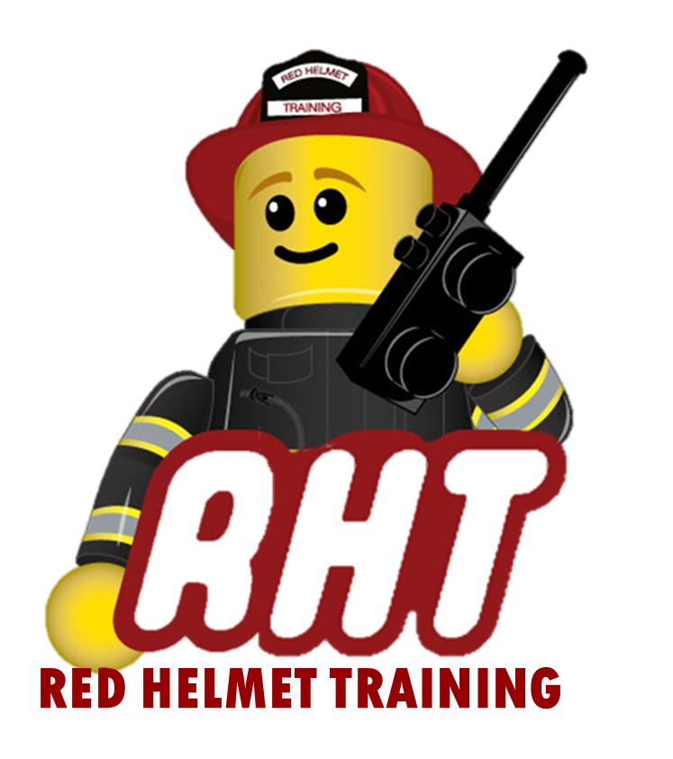
Red Helmet Training
Wildland Fire Courses

Announce: S-270 Basic Air Operations

Dates: November 10th and 11th, 2025

Times: 8:00 a.m. – 5:00 p.m.

Location: Red Helmet Training Central (Fresno)
3437 West Shaw Ave. Fresno

Instructor: Mike Reimer

Fees / Materials: $260.00 – Payable to Red Helmet Training
Covers cost of NWCG Training Material and CSFM certificate of completion.

Class Description: This course covers aircraft types and capabilities, aviation management and safety for flying in and working with aircraft. The class discusses agency tactical and logistical uses of aircraft and requirements for helicopter take-off and landing areas.

This course is required for many CICCS, NWCG and FIRESCOPE positions.

To register for this course please visit the web site.
www.RedHelmetTraining.com

Red Helmet Training

Playing to Learn, Learning to Play



