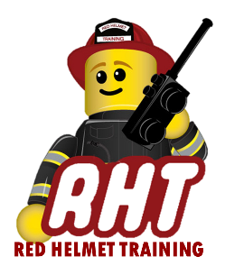
Red Helmet Training

Fire Prevention Courses

Announce: Plans Examiner 1B – Plan Review for
Fire Protection and Life Safety Systems

Dates: May 29, 30, and 31, 2026 (F, S, Su)

Times: 8:00 a.m. – 5:00 p.m.

Location: Red Helmet Training Classrooms
8560 Vineyard Avenue #306
Rancho Cucamonga, CA 91730

Instructor: Brian Pachman

Course Fees: $375.00 – Payable to Red Helmet Training

Materials: Current California Fire and Building Codes
Engineers and Architectural Scale, Calculator
NFPA 13, 14, 17A and 72

Class Description: This course provides the knowledge and skills that prepare a plan examiner to evaluate fire flow compliance and identify requirements and review installation plans for fire protection and life safety systems.

Prerequisite: Plans Examiner 1A

To register for this course please visit the web site.
www.RedHelmetTraining.com



Red Helmet Training

Playing to Learn, Learning to Play

